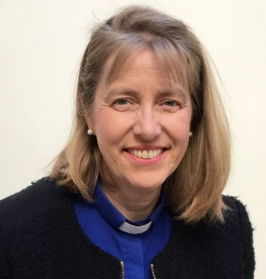
DECEMBER/JANUARY
Letter from The Vicarage.
Happy Christmas with love and prayers for a peaceful New Year!
This issue takes us through the excitement and festivities of Christmas, through the New year and January 2022. 2022! Is it just me or does the passing of time accelerate as we get older?
As we get older, and at the close of each passing year, we often stop and reflect on our journey through life so far. The good and the bad. Jesus had a short life on earth (approx. 33 years) that came to a horrible end on a cross. Amazingly, being fully divine as well as fully human he rose victorious and is alive - conquering death for ever. This only starts to make sense when we consider how very small, we are and how very big God is. We only have to look at the sun, moon and stars or the intricate design of nature to even begin to imagine how big God is. It is interesting that there is a bible verse that says
“It is easier for a camel to pass through the eye of a needle that for a rich person to get into the kingdom of God.” Matthew 19:24
Being well off or at least comfortable with a roof over our heads, Christmas food on the table, and presents under the tree may mean that we miss the real point of Christmas - JESUS. A relationship with Him can bring whole life transformation - from a young child through to old age. The Lord invites us to put our trust in Him. Knowing Jesus will last well beyond December and January 2022 - but throughout the years we have left and for eternity.
Sway is a generous village with a warm heart to help others. It is a wonderful place where the community come together to offer Christmas lunches, hampers and other initiatives to love our neighbours. It really is a place where the call to ‘love thy neighbour’ is seen in action. THANK YOU SWAY. x
You are warmly invited to any of the St Luke’s Christmas services and events. You are also invited to make 2022 a year to explore your own spirituality and what Christianity has to offer you….. follow us on Facebook and see our website for details. Hopefully there is something for everyone.

Happy Christmas and every blessing for 2022
Vicar Jane
www.stlukessway.org.uk

