WELCOME TO THE PARISH NEWS FOR ST LUKE'S CHURCH, SWAY
SUNDAY 27th July 2025
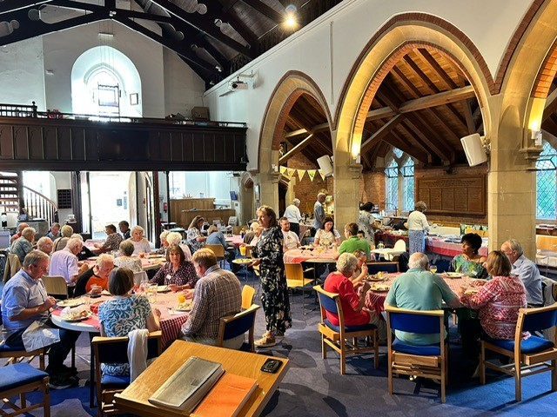
Happy with your lot?
That is the title of Sunday's talk - how we are challenged with being content with our possessions, our work and our relationships and having hearts of gratitude. If we are honest it is difficult- but this is the discipleship that God calls on those who are committed to him. His word can bring hope and encouragement.
This is in our series studying wisdom scripture in the bible.
Thank you to all those who made last Sunday evening's Parish Summer meal such a such a lovely time together. Although the weather was unreliable to be outside in the Vicarage Garden - the setting in the church was a blessing.
Love and prayers
Vicar Jane
WORSHIP
"Wisdom for Today: Biblical Truth for Modern Life"
Money Success and True Wealth
Proverbs 11: 28 and Ecclesiastes 5: 10-20
Luke 11: 1-13
9.30am Informal Service
Leader & Speaker Revd. Jane Mitchell
10.30am Coffee Time
11am Morning Service
Leader & Speaker Revd. Jane Mitchell
Please click on the link below to see worship for August 2025
CLICK HERE to see worship for August
Printed copies can also be found in church
Please note that there is no 9.30am service on the 24th August.
Prayer
Creator God,
you made us all in your image:
may we discern you in all that we see,
and serve you in all that we do;
through Jesus Christ our Lord.
Would you like to join Thursday morning prayers online?
Here is the link for Thursday online parish prayers. We normally reflect on the bible passage for the coming Sunday and pray through the church monthly calendar.
https://zoom.us/j/95044393409? pwd=ekVMbFBacHZaeDF0aUM4bTluWU14QT09
This week please pray for :
Lydia and family
Give thanks for the PCC and finance team
Those we love who are receiving end of life care
Rwanda trip in Aug- for planning and preparation. For Jane, Jonathan, Rosemary, Kevin, Lisa Thomas and the group.
CHURCH NEWS
Please note the church office will be open during the summer holidays on Mondays, Wednesdays and Friday mornings 10-12. Thank you to Heather Andrews and Sheila Green for covering these hours. After this the office will reopen fully on 3rd September. At other times for urgent pastoral care please ring Jane on 07885 505532 or Russell Fry- Churchwarden on 07720597864.
ANNOUNCEMENT: FAMILY AND COMMUNITY SUPPORT WORKER
We are delighted to announce that Lizzy Smith as been appointed and starts in September. Lizzy's focus will be on developing Messy Church and supporting the links we have with the school. Lizzie will be working 4 hours a week on Wednesday mornings in the office from September. Thank you Lizzy and we pray you will be blessed in this essential new role supporting the family and community work at St Luke's. 🙏
Church Land: The PCC continue to develop ideas and listen to the views of parishioners. The land will continue to be used for the community and the building still has many years of life in it. Conversations continue with the Parish Council to work out the best way to serve the church and the village. More details to follow soon.
New Wine Festival - 30th July-4th August
Join us if you can at the New Wine Festival! A group from church will be attending on Saturday 2nd August. If you would like to join us please contact the church office on office@swaychurch.com or Ellie John on elliejohn819@gmail.com
CLICK HERE for tickets or to see more
Invitation to special exhibition, tour and talk with artist for the church community Friday 1st August - a message from Suna at Spudworks
We have a really lovely, moving and thoughtful exhibition coming up and we would like to invite members of the church to come for a special talk and tour with the artist on Friday 1st of August between 11am and 12 noon. If you would like to come then email me at suna@spud.org.uk just to confirm attendance. This is a free event and there will be also be refreshments. I really hope some of the church community can make it!


Urgent Prayer Circle
We have a new wonderful team for our urgent prayer circle. If you are in need of urgent prayer, then in the first instance contact Jane on 07885505532 or the church office on 01590 682358, or if you are unable to make contact with Jane or the office then please email Jennie McNaught on mcnaughthome@protonmail.com
New Forest Basics Food Bank - please donate in our box at the back of church.
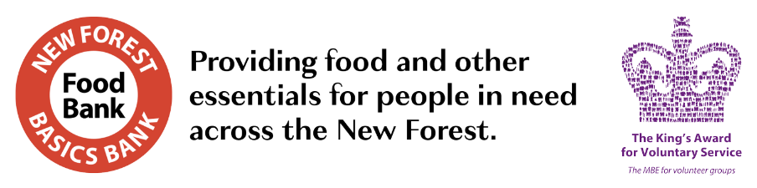
Food bank items in urgent need
The next Alpha course at St Luke's starts 10th September 2025

The Alpha course, is an opportunity for anyone to explore the Christian faith. It's relaxed, low key, friendly and fun. Listen, learn, discuss and discover. And ask anything. Alpha is a place where no question is too simple or too hostile. And it's supported by all the main Christian denominations.
CLICK HERE TO SIGN UP FOR ALPHA
10.30am Sunday Coffee Team Volunteers Needed!
Thank you for all the volunteers but we still need more! As you know we are looking for new volunteers to join our coffee team! If you think you can help please let the church office know - office@swaychurch.com or 01590 682358 We would love to hear from you!
Coming up in the next week....
Sunday 27th July
9.30am Informal Service
11am Morning Service
Tuesday 29th July
10am Community gardening
10.30am Community Cafe
Wednesday 30th July
9am Parish Prayers
New Wine Festival - Bath and West Showground - All Day
Thursday 31st July
9am Online Morning Prayers
New Wine Festival - Bath and West Showground - All Day
Friday 1st August
New Wine Festival - Bath and West Showground - All Day
10am Friday Service
7.30pm Choir Rehearsal
Sunday 3rd August
New Wine Festival - Bath and West Showground - All Day
9.30am Informal Service
11am Parish Communion
Monday 4th August
New Wine Festival - Bath and West Showground - All Day
Tuesday 5th August
10am Community gardening
10.30am Community Cafe
Wednesday 6th August
9am Parish Prayers
12pm Lunch Club
Thursday 7th August
9am Online Morning Prayers
Sunday 10th August
9.30am Informal Service
11am Morning Service

