WELCOME TO THE PARISH NEWS FOR ST LUKE'S CHURCH
SUNDAY 14th DECEMBER 2025
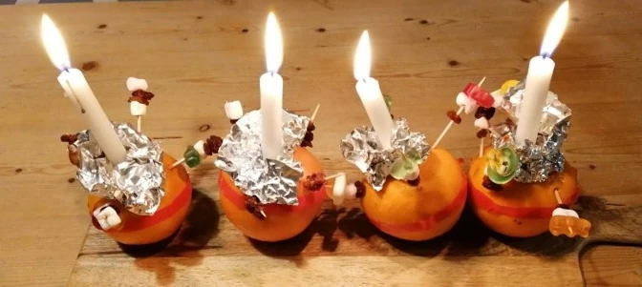
Come and join the fun at Messy Christingle this Sunday 14th Dec at 9.30am
As we enter the season of Advent, we look forward with hopeful expectation to the coming of Christ, both in the humble joy of the Nativity and in the promise of His future kingdom. Advent invites us to pause amid the busyness of winter, to watch and to wait, and to make room in our hearts through prayer, reflection, and acts of kindness. As the candles on the Advent wreath grow ever brighter, may we be reminded of God's light breaking into the world and of the hope, peace, joy, and love we are called to share. This weekend we are especially delighted to welcome newcomers and families to our Christingle and Carols services, as we gather to celebrate the light of Christ shining in our community.
Love and prayers,
Sara
Worship
Sunday 14th December
3rd Sunday of Advent
Advent Morning Service
James 5:7-10
Matthew11:2-11
8am Holy Communion
Rev Chris Guinness
9.30am Messy Christingle
Leader Lizzy Smith
10.30am Coffee in Church Rooms thank you to our coffee team Sheila, Alison, Belinda and Enid
11am Advent Morning Service
Leader Sue Cornwell & Speaker Revd. Jane Mitchell
6.30pm Carols by Candlelight with St Luke's Church Choir
Warm fruit punch served afterwards in the church rooms
NEXT SUNDAY 21st Dec
8am Holy Communion
10am Carols and Cake - wear your Christmas jumpers
CLICK HERE to see all of December Worship
CLICK HERE to see our Christmas Services
Paper copies for all services are available at the back of church.
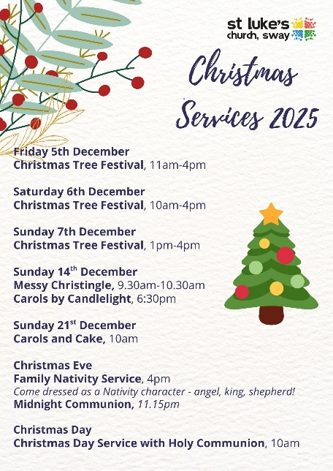 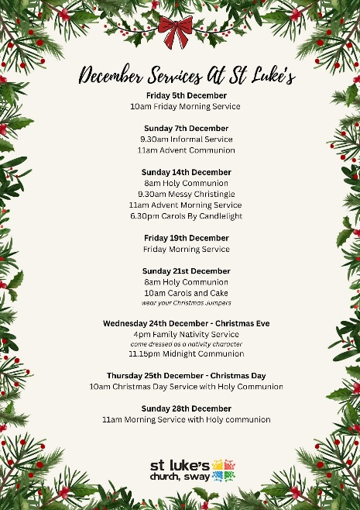
Prayer

The Third Sunday of Advent
God for whom we watch and wait,
you sent John the Baptist to prepare the way of your Son:
give us courage to speak the truth,
to hunger for justice,
and to suffer for the cause of right,
with Jesus Christ our Lord.
Amen.
Thursday morning online prayers
A reflection on the bible passage for the coming Sunday and prayers using the church monthly prayer guide for the Parish.
CLICK HERE to join online prayers
Please pray for;
Lydia and family
Thanks for the generosity of givers supporting St Luke's and enabling ministry
The Parish Council
Kibirizi Parish building the church
Newcomers to our church Christmas services
This week from our monthly prayer diary (copies available in church)
Newcomers;
We pray for all the welcomers, volunteers and hospitality team who work and offer hospitality at St Luke's in so many different ways to enable our newcomers and visitors to rest and meet with God. We pray that St Luke's is a place of encounter, of healing and of new life in the name of Jesus. Come Holy Spirit and bless our newcomers and visitors.
Church News
The church office will close for Christmas on Tuesday 23rd December and reopen on Monday 5th January. The next Parish News for Sunday 21st December will be the last one of the year. The Parish News will resume again on Sunday 11th January 2026.
Carols by candlelight Sunday 14th December at 6.30pm
You're warmly invited to join us for our Carols by Candlelight service, a beautiful evening of music, light, and community. Refreshments served afterwards in the church rooms.
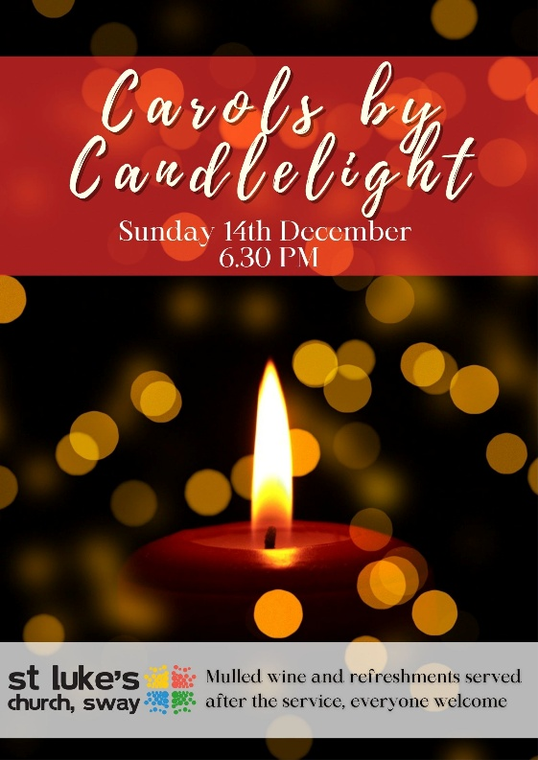
St Luke's Church Choir will be spreading festive cheer this Christmas as they sing carols at Birchy Hill Care Home and Sway Place. Please keep the choir and the residents in your prayers as they share the joy and hope of the season.
SWAY PLACE on Monday 15th December at 10.30am
BIRCHY HILL on Monday 22nd December at 11.30am
Carols and Cake Service Sunday 21st December at 10am
Join us for our Carols and Cake service, come along for music, treats, and Christmas joy, and feel free to wear your favourite Christmas jumper!
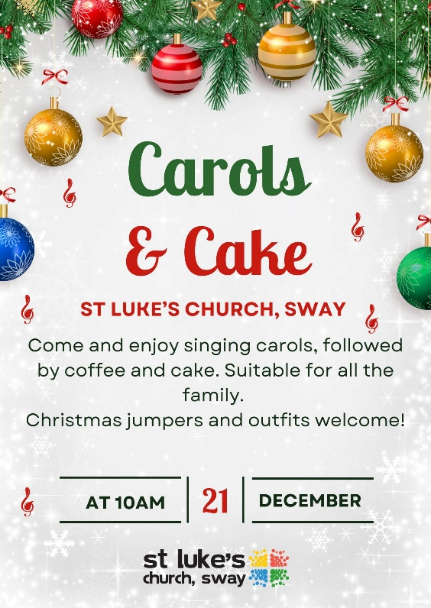
Christmas Eve Nativity Service 4pm
We invite all the family, young and old, to our Nativity Service on Christmas Eve, come dressed as your favourite character from the Nativity story!

Midnight Mass 11.15pm on 24th December
Join us for Midnight Mass on Christmas Eve at 11:15pm, as we gather in peaceful reflection to welcome the joy of Christmas.
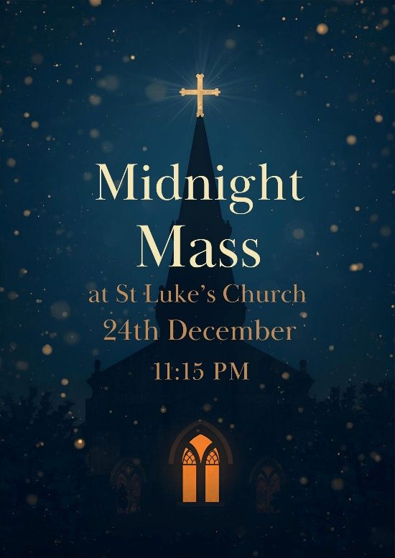
Christmas Day Service 10am - 25th December
We warmly invite you to join us for our Christmas Day service as we celebrate the joy and hope of Christ's birth together
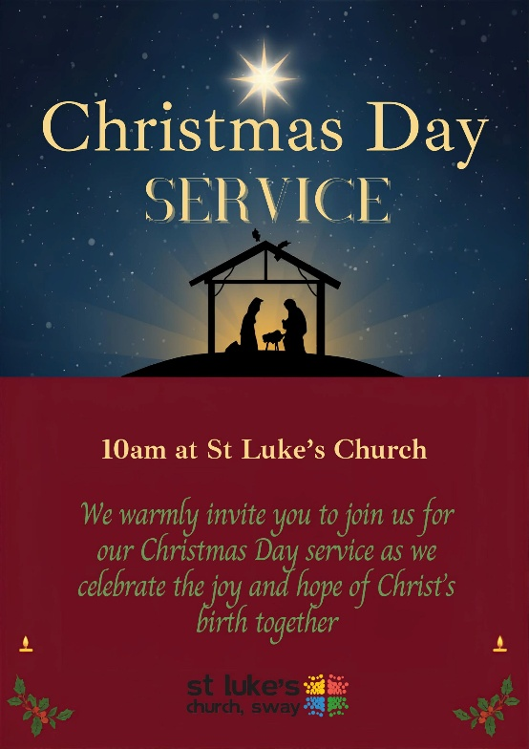
St Luke's Church Choir
A date for your diary-Saturday 10th January 2026 12.30pm


Following our successful Lunchtime Concert back in October, I have already started rehearsals with the choir for our second one next month.
The theme will be Epiphany, as most of our music is about the Wise Men following the star to Bethlehem to present gifts to Baby Jesus,
We will be singing well-known Epiphany carols such as: We 3 Kings, As with gladness, men of old, Brightest and best are the sons of the morning. Also Harold Darke's beautiful arrangement of - In the bleak midwinter and John Rutter's famous Star Carol.
We welcome on board local eminent organist Andrew Elliott who will be accompanying and delighting us with a seasonal organ solo.
Come and listen to some beautiful music in the church on Saturday 10th January at 12.30pm.
A relaxed half hour to brighten your day!
Rosemary Elliott-Jones
SWAG Soup & Sandwich - Next date is Tuesday 13th January at 12pm
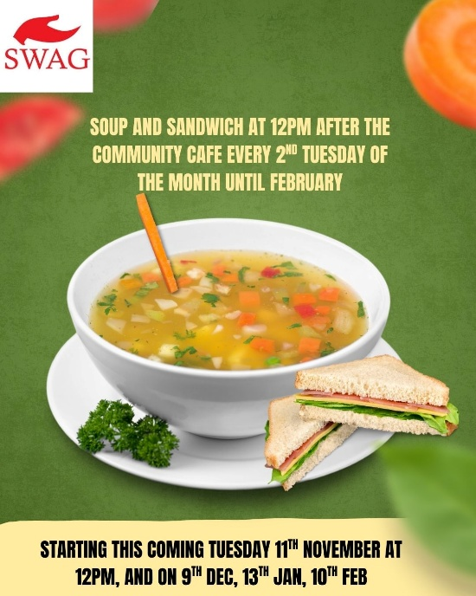
SWAG Community Cafe are offering a soup and sandwich lunch from 12pm. This will be offered after the Community Cafe on the 2nd Tuesday of the month running through until February. The dates are; 13th January, & 10th February.
We hope to see you there.
Urgent Prayer Requests
If you, or someone you know is in need of urgent prayer then please contact Jane on 07885505532 or the church office on 01590 682358, or if you are unable to make contact with Jane or the office then please email Jennie McNaught on mcnaughthome@protonmail.com.
_{Death and Life course}
Death and Life Course begins 10th February, 2pm–3.30pm (6 weeks) The PCC has agreed to the pastoral team's proposal to offer a gentle, practical six-week course on preparing for the end of life. It's a sensitive topic, but an important one. As Christians, we hold to the hope of the gospel and can face these conversations with honesty and without fear, supporting one another with compassion. Each week we will welcome a different speaker to guide us through key aspects of end-of-life planning, including:
- A solicitor – making a will and setting up powers of attorney
- A local funeral director – understanding the role of an undertaker
- A GP – how to approach difficult but important conversations with family and friends
- A hospice representative – insight into hospice care and support
- Vicar Jane – planning an order of service that reflects your wishes
The course will take place in church, with tea and cakes served each week.
All are welcome. More details to follow.
A Request From The Friends Of Sway Station
Friends of Sway Station are trying to understand barriers to use of the trains at Sway station. Please take a moment to complete our short survey to help us understand why people are not using the train at Sway Station. Please click on the link below which will take you straight to the survey. The station is now in the bottom 10% of stations by use in Hampshire and we want to push it up the league table for fear of losing services.
Many thanks,
Neil McLocklin
CLICK HERE to complete a short survey
Children and Families
We'd love to welcome you to join us for one of our Christmas celebration services as we come together to share the joy and hope of the season.
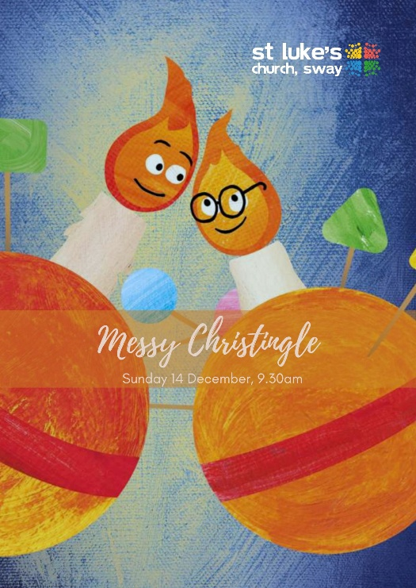
Messy Christingle this coming Sunday 14th December 9.30am -sign up link below
Baby Bump and Toddler Christmas Nativity Celebration
Monday 15th Dec at 9.30am -sign up link below
Nativity Service Christmas Eve at 4pm
Sign up here for Messy Christingle
Sign up here for Baby Bump and Toddler Nativity Celebration

Mission News
Join us for fund raising fun at the Hare and Hounds on Thursday 18th Dec. A group of us will be carol singing there and passing the hat round in support of the Church Building at Kibirizi Parish. Join us after 6pm!
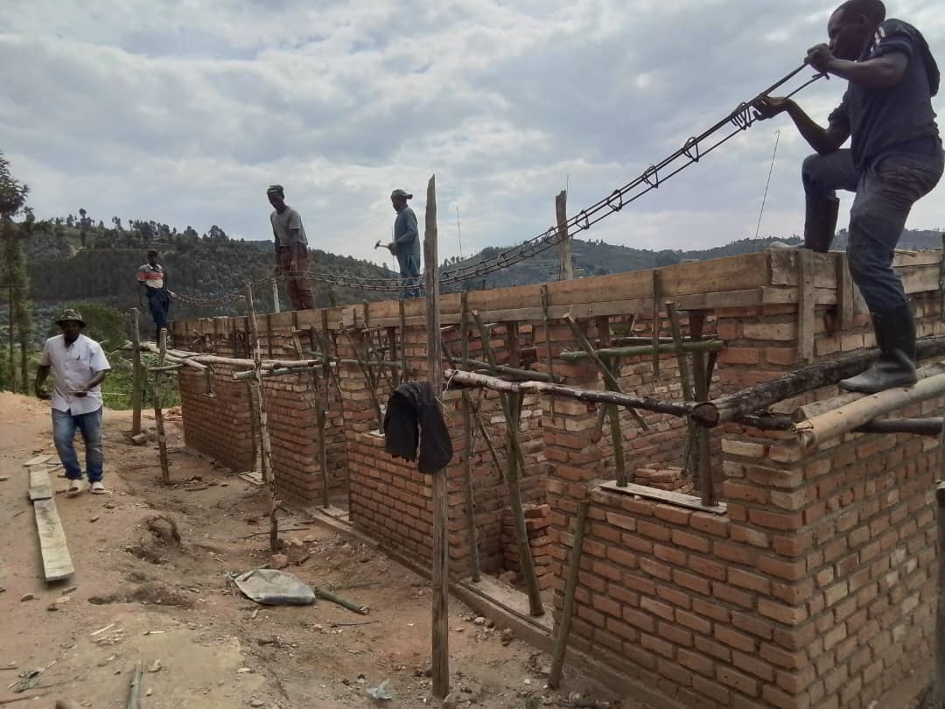

Building Hope in Kibirizi: Your Support is Making a Difference
Thanks to the generosity of this congregation, work is once again progressing rapidly on the new church in our link parish of Kibirizi, rural Rwanda.
The £1,000 raised at the Family Brunch a few weeks ago together with further donations that have doubled this amount is already being used to purchase roofing materials, doors, windows, and other essential supplies. Current efforts are focused on completing the rooms at the back of the church, which are already serving the community by providing space for counselling families facing conflict and difficulties.
Even in its unfinished state, the new building is already a blessing to the people of Kibirizi. With continued support, we can help ensure they have a permanent place to worship, find hope, and grow together.
Please consider making a donation, praying for the project, or sharing this appeal to keep the vision alive.
Parish Fundraising Success – Bags of Difference
We are delighted to share that sales of "Bags of Difference" items raised £233. This money will be sent before Christmas to Kisiizi Hospital, where the staff who made them will receive a well-deserved boost recognising their hard work making the bags and other items.
A heartfelt thank you to everyone who purchased these wonderful, colourful creations—whether for your own use or as gifts. Your support has made a real difference and brought joy both here and in Kisiizi.
Thanks Jonathan
PPC NEWS
Church Land - Youth Centre update
Update on the Youth Centre Building and Future Planning
Thank you to everyone who joined the meeting on 3rd December. After recent correspondence from the Parish Council confirming that repairs would not be included in a 15-year lease, the PCC has decided to pause progress on Option 1 while further conversations take place in the New Year. We hope to continue using the current building for as long as possible, support existing users with as little disruption as possible, keep the car park and allow time to understand the needs of the new pre-school and to reflect on longer-term plans. The PCC will appoint a working party in the New Year to help explore options. Thank you for your support and prayers as we plan for the future.
Dates for the Diary
Next Week:
Monday 15th December | 9.30am Baby Bump and Toddler Christmas Nativity and Party  10.30am Sway Place Christmas Carols with St Luke's Church Choir
Tuesday 16th December | 10am Community Gardening  10.30am SWAG Cafe  2pm St Luke's School Carol Service in church  6pm St Luke's School Carol Service in church
Wednesday 17th December | 9am Parish Prayers  1.45pm Open The Book Rehearsal
Thursday 18th December | 9am Online Prayers  6.30pm Choir Led Carols at The Hare and Hounds  7pm Band Practise
Friday 19th December | 9.30am Baby Bump and Toddler  10am Friday Morning service  12pm Little Flyers Pre-School Nativity in Church  7.30pm Choir Practise
Future Dates:
Sunday 21st December | 8am Holy Communion  10am Carols and Cake
Monday 22nd December | 11.30am Birch Hill Christmas Carols with St Luke's Church choir
Tuesday 23rd December | Church Office Closed until 5th Jan  9am Parish Prayers
Wednesday 24th December | 4pm Nativity Service  11.15pm Midnight Mass
Thursday 25th December | 10am Christmas Day Celebration Service with Holy Communion
Friday 26th December
Saturday 27th December
Sunday 28th December | 11am Morning Service with Holy Communion
Please check the website or churchsuite for all other events and dates.
Contact Information
VICAR: REVD JANE MITCHELL (Rest day: Friday) vicar@swaychurch.com | 07885 505532
OFFICE ADMINISTRATOR: SARA WILLIS office@swaychurch.com |01590 682358
Family and Community Support Worker: Lizzy Smith - Wednesday mornings 01590 682358

