WELCOME TO THE PARISH NEWS FOR ST LUKE'S CHURCH
SUNDAY 21st DECEMBER 2025
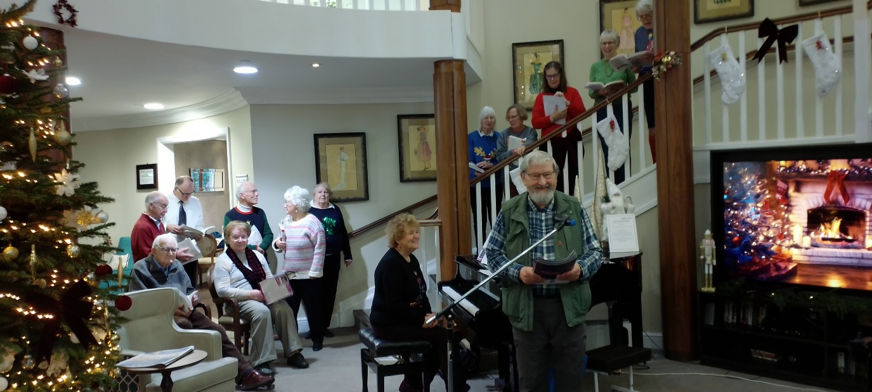
St Luke's Church Choir singing carols at Sway Place
Dear Friends at St Luke's,
I would like to take this opportunity to wish everyone at St Luke's a very happy, peaceful, and blessed Christmas. As I come up to a year in my role as Office Administrator this coming February, I would like to thank you all sincerely for your kindness, patience, and continued support as I have settled in. It has been a real pleasure to get to know so many of you, and I am very grateful to be part of such a welcoming and supportive parish community. I wish you all every blessing for the year ahead.
Love and prayers,
Sara
Worship
Sunday 21st December
4th Sunday of Advent
Carols and Cake Service
Everyone is warmly invited to join us for our Carols and Cake service, a joyful celebration for neighbours, friends, and families.
8am Holy Communion
Leader & Speaker Revd. Jane Mitchell
10am Carols and Cake Service wear your Christmas Jumpers
Leader Sue Cornwell, Speaker Revd. Jane Mitchell, Music from Rosemary and St Luke's Choir
11am Coffee and Cake in the Church thank you to our coffee team Lucy, Sara and Ken
Services coming up:
Wednesday 24th December
4pm Nativity Service for all the family - come dressed as a character from the Christmas Story
11.15pm Midnight Communion
Thursday 25th December
10am Christmas Celebration Service with Holy Communion
Sunday 28th December
11am Morning Service with Holy Communion
Paper copies for all services are available at the back of church.
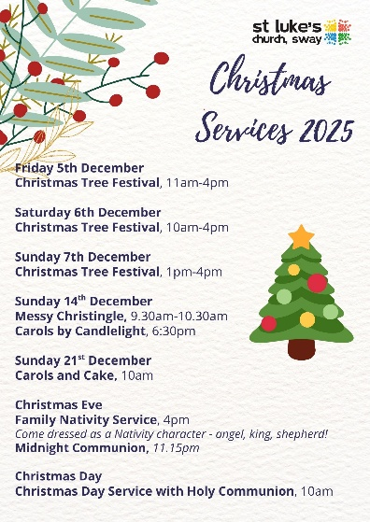 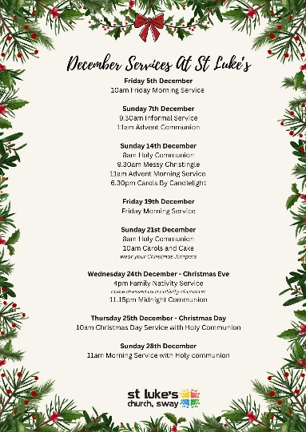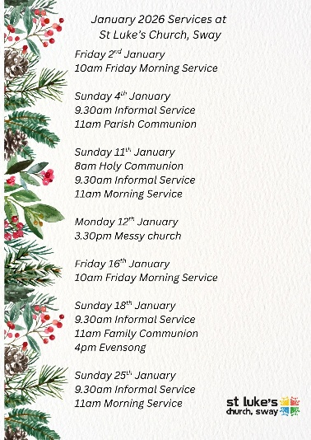
Prayers for Christmas
The fourth Sunday of Advent
Eternal God,
as Mary waited for the birth of your Son,
so we wait for his coming in glory;
bring us through the birth pangs of this present age
to see, with her, our great salvation
in Jesus Christ our Lord.
Christmas Eve
Almighty God,
as we prepare with joy
to celebrate the gift of the Christ-child,
embrace the earth with your glory
and be for us a living hope
in Jesus Christ our Lord.
Christmas Eve Night
Eternal God,
in the stillness of this night
you sent your almighty Word
to pierce the world's darkness with the light of salvation:
give to the earth the peace that we long for
and fill our hearts with the joy of heaven
through our Saviour, Jesus Christ.
Christmas Day
Lord Jesus Christ,
your birth at Bethlehem
draws us to kneel in wonder at heaven touching earth:
accept our heartfelt praise
as we worship you,
our Saviour and our eternal God.
First Sunday of Christmas
God in Trinity,
eternal unity of perfect love:
gather the nations to be one family,
and draw us into your holy life
through the birth of Emmanuel,
our Lord Jesus Christ.
Please note ;
There will be no Thursday online prayers on 25th December and 1st January
There will be no Parish Prayers on 24th December or 31st December
Please pray for;
Lydia and family
Thanks for the generosity of givers supporting St Luke's and enabling ministry
Kibirizi Parish building the church
Newcomers to our church Christmas services
Those Who Are Lonely or Isolated
Families in Need
Refugees, Migrants, and the Homeless
This week from our monthly prayer diary (copies available in church)
Musical Worship:
Today we pray for the choir and the different Worship groups. We pray that those using their gifts of music are drawn into a loser relationship with you. We pray blessing for those in leadership who teach and encourage musical worship. Thank you for the wonderful music and the role music plays in enhancing worship.
Church News
The church office will close for Christmas on Tuesday 23rd December and reopen on Monday 5th January. This edition of the Parish News will be the last one of the year. The Parish News will resume again on Sunday 11th January 2026.
Carols and Cake Service Sunday 21st December at 10am
Everyone is warmly invited to join us for our Carols and Cake service, a joyful celebration for neighbours, friends, and families. Even if you don't usually come to church, you are most welcome to share in the music, laughter, and festive cheer. Come and enjoy the fun as we gather together as a community this Christmas, and don't forget o wear your Christmas jumpers!
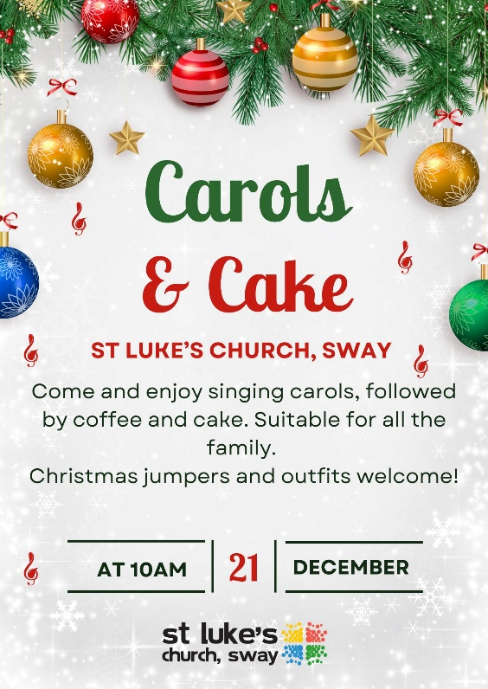
St Luke's Church Choir will be spreading festive cheer this Christmas as they sing carols at Birchy Hill Care Home and Sway Place. Please keep the choir and the residents in your prayers as they share the joy and hope of the season.
BIRCHY HILL on Monday 22nd December at 11.30am
Christmas Eve Nativity Service 4pm
We invite all the family, young and old, to our Nativity Service on Christmas Eve, come dressed as your favourite character from the Nativity story!

Midnight Communion 11.15pm on 24th December
Join us for Midnight Communion on Christmas Eve at 11:15pm, as we gather in peaceful reflection to welcome the joy of Christmas.
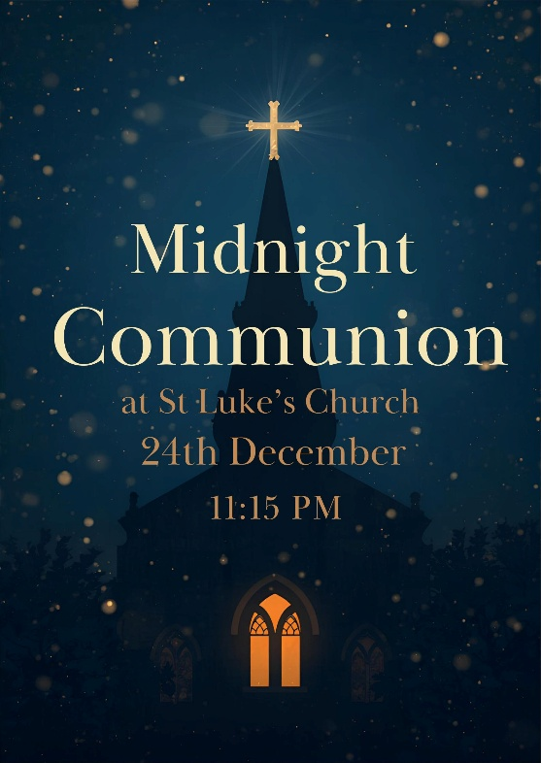
Christmas Day Service with Holy Communion
10am on 25th December
We warmly invite you to join us for our Christmas Day service as we celebrate the joy and hope of Christ's birth together
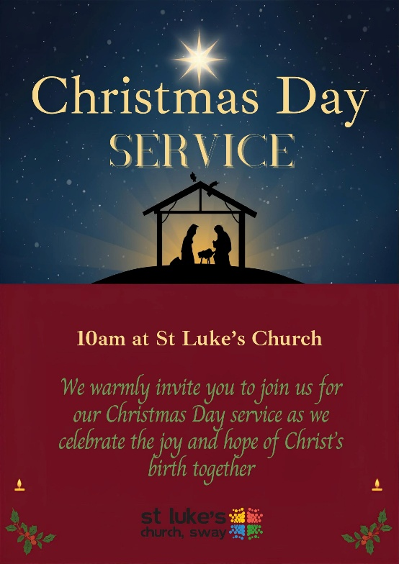
St Luke's Church Choir
A date for your diary-Saturday 10th January 2026 12.30pm


Following our successful Lunchtime Concert back in October, I have already started rehearsals with the choir for our second one next month.
The theme will be Epiphany, as most of our music is about the Wise Men following the star to Bethlehem to present gifts to Baby Jesus,
We will be singing well-known Epiphany carols such as: We 3 Kings, As with gladness, men of old, Brightest and best are the sons of the morning. Also Harold Darke's beautiful arrangement of - In the bleak midwinter and John Rutter's famous Star Carol.
We welcome on board local eminent organist Andrew Elliott who will be accompanying and delighting us with a seasonal organ solo.
Come and listen to some beautiful music in the church on Saturday 10th January at 12.30pm.
A relaxed half hour to brighten your day!
Rosemary Elliott-Jones
SWAG Soup & Sandwich - Next date is Tuesday 13th January at 12pm

SWAG Community Cafe are offering a soup and sandwich lunch from 12pm. This will be offered after the Community Cafe on the 2nd Tuesday of the month running through until February. The dates are; 13th January, & 10th February.
We hope to see you there.
Urgent Prayer Requests
If you, or someone you know is in need of urgent prayer then please contact Jane on 07885505532 or the church office on 01590 682358, or if you are unable to make contact with Jane or the office then please email Jennie McNaught on mcnaughthome@protonmail.com.
Safeguarding
If you have any safeguarding concerns over the Christmas period, please do not hesitate to contact our Parish Safeguarding Officer, Sara Willis at safeguarding@swaychurch.com who will ensure your concern is taken seriously and responded to promptly. This mailbox will be monitored over the Christmas period. However, if you or someone else is in imminent danger, phone the police on 999, or call them on 101 if it is less urgent. You can also reach the Diocese Safeguarding Adviser Jackie Rowlands for further guidance and support. Her contact details can be found on our website, a link to which is attached below. Safeguarding is everyone's responsibility, and your vigilance helps keep our church a safe and welcoming place for all. Thank you.
CLICK HERE to go to St Luke's Church Safeguarding Page
_{Death and Life course}
Death and Life Course begins 10th February, 2pm–3.30pm (6 weeks) The PCC has agreed to the pastoral team's proposal to offer a gentle, practical six-week course on preparing for the end of life. It's a sensitive topic, but an important one. As Christians, we hold to the hope of the gospel and can face these conversations with honesty and without fear, supporting one another with compassion. Each week we will welcome a different speaker to guide us through key aspects of end-of-life planning, including:
- A solicitor – making a will and setting up powers of attorney
- A local funeral director – understanding the role of an undertaker
- A GP – how to approach difficult but important conversations with family and friends
- A hospice representative – insight into hospice care and support
- Vicar Jane – planning an order of service that reflects your wishes
The course will take place in church, with tea and cakes served each week.
All are welcome. More details to follow.
A Request From The Friends Of Sway Station
Friends of Sway Station are trying to understand barriers to use of the trains at Sway station. Please take a moment to complete our short survey to help us understand why people are not using the train at Sway Station. Please click on the link below which will take you straight to the survey. The station is now in the bottom 10% of stations by use in Hampshire and we want to push it up the league table for fear of losing services.
Many thanks,
Neil McLocklin
CLICK HERE to complete a short survey
Children and Families
We'd love to welcome you to join us for one of our Christmas celebration services as we come together to share the joy and hope of the season.
Nativity Service Christmas Eve at 4pm

Baby, Bump and Toddler resumes on Monday 5th January at 9.30am in the church rooms.
Next Messy Church is Monday 12th January at 3.30pm. We hope to see you there!
Mission News
Remembering Our Mission Partners This Christmas
As we prepare to celebrate the birth of Christ, we give thanks for our mission partners across the world. Their faith, service, and witness remind us of the global family we belong to in Christ.

Kibirizi Church, Rwanda
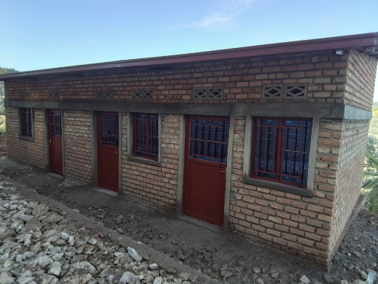
Our link parish in Rwanda continues to flourish. Pastor Vianney has sent us warm greetings and news of their preparations for Christmas and the progress on their church building project:
"I'm pleased to greet you and wish you a good week and joyful preparations for Christmas to you and your entire family.
We are also doing well, preparing for Christmas and continuing with the church building, as you will see in the photos we're sending showing the progress. The church offices are looking very good, as you can see, and the strength behind all of this is yours, our dear friends and partners who are helping us build the house of God. We are always grateful to you, day and night. Thank you, our dear friends.
We will start using these office buildings on Tuesday this week, and we are so happy to once again have spaces where we can work and store the church's equipment.
We will celebrate Christmas with you this year, rejoicing in the great work God has done in the church through you, who accepted to be His messengers to us. May the Lord look upon you kindly. May the end of the year be full of blessings for you, and may you finish it well and start the new one in peace—that is our prayer for you.
I conclude by wishing you peace and blessings.
Yours,
Pastor Vianney"

Bev Cannon, Ecuador
A former member of our congregation, Bev took the bold step of moving to South America to serve the Lord with CMS. She continues her ministry in Cuenca, Ecuador. You can read her latest newsletter by clicking on the link below.
CLICK HERE to read Bev Cannon's latest newsletter

Kisiizi Hospital, Uganda
Since 1973, we have supported Kisiizi Hospital, a church-run hospital serving the community in Uganda. Read more about the hospital's work by clicking on the link below. We look forward to welcoming Dr Ian Spillman to St Luke's on Sunday 8th March. After our service, we will share a Lent Lunch and hear more about the hospital's inspiring work.
Get a flavour of what's in store that day at Kisiizi Hospital's website.
CLICK HERE to read more about the hospitals work
We pray for their work at this Christmastide:
Lord of all nations,
We thank You for the gift of our mission partners and the joy of sharing in their witness.
Bless Pastor Vianney and the parish of Kibirizi, Bev Cannon in Ecuador, and the staff and patients of Kisiizi Hospital in Uganda.
May their work continue to flourish, and may our fellowship in Christ strengthen across every distance.
As we celebrate the birth of Your Son, fill us with peace, generosity, and hope,
that together we may build Your kingdom on earth.
Through Jesus Christ our Lord. Amen.
PCC NEWS
Church Land - Youth Centre update
Update on the Youth Centre Building and Future Planning
Thank you to everyone who joined the meeting on 3rd December. After recent correspondence from the Parish Council confirming that repairs would not be included in a 15-year lease, the PCC has decided to pause progress on Option 1 while further conversations take place in the New Year. We hope to continue using the current building for as long as possible, support existing users with as little disruption as possible, keep the car park and allow time to understand the needs of the new pre-school and to reflect on longer-term plans. The PCC will appoint a working party in the New Year to help explore options. Thank you for your support and prayers as we plan for the future.
Dates for the Diary
Next Week:
Monday 22nd December | 1.30am Birch Hill Christmas Carols with St Luke's Church choir
Tuesday 23rd December | Church Office Closed until 5th Jan  9am Parish Prayers  11am Funeral David May
Wednesday 24th December  Christmas Eve | 4pm Nativity Service  11.15pm Midnight Communion
Thursday 25th December  Christmas Day | 10am Christmas Day Celebration Service with Holy Communion
Friday 26th December
Boxing Day
Future Dates:
Sunday 28th December | 11am Morning Service with Holy Communion
Monday 29th December
Tuesday 30th December
Wednesday 31st December
New Years Eve
Thursday 1st January
New Years Day
Friday 2nd January | 10am Friday Morning Service  7.30pm Choir Practise
Saturday 3rd January
Sunday 4th January | 9.30am Informal Service  11am Parish Communion
Please check the website or churchsuite for all other events and dates.
Contact Information
VICAR: REVD JANE MITCHELL (Rest day: Friday) vicar@swaychurch.com | 07885 505532
OFFICE ADMINISTRATOR: SARA WILLIS office@swaychurch.com |01590 682358
Family and Community Support Worker: Lizzy Smith - Wednesday mornings 01590 682358

